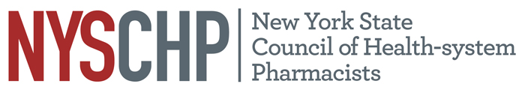
230 Washington Ave Extension, Albany NY 12203 - 518-456-8819

December 2020 Virtual House of Delegates
AGENDA

Order of Business
December 3rd, 2020
4:00 PM- 6:00 PM

1. Call to Order
2. Greetings
3. Roll call of the delegates
4. Proposed changes to the NYSCHP C&B review
5. Position statement review
6. Unfinished Business
7. New Business
8. Announcements
9. Adjournment

